# Name of game: Jozo’s Adventure

# Story

Jozo is a game character. He and his friends went to an unknown island to travel, while traveling his friends got caught by the Tribal chief of that island, and to recuse his friends, he has to bring the crystals asked by a tribal chief. Jozo and his chimp have to go through hardship and obstacles to save their friends from the Tribal chief. This is how the bizarre adventure of Jozo started.

# About Game:

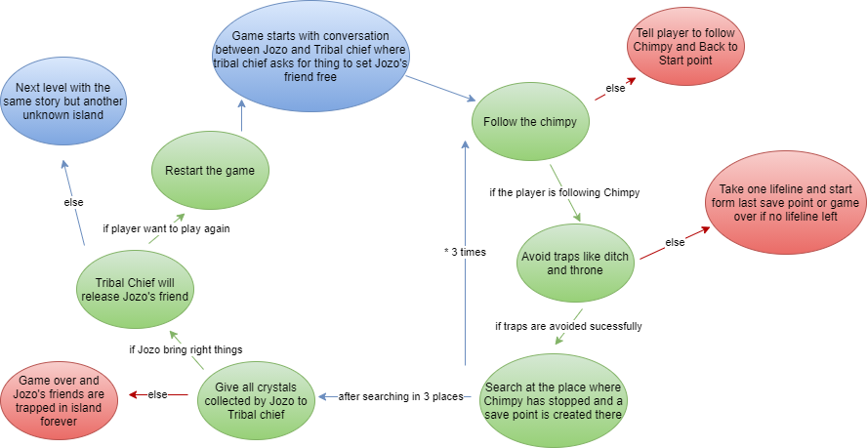

# Game loop

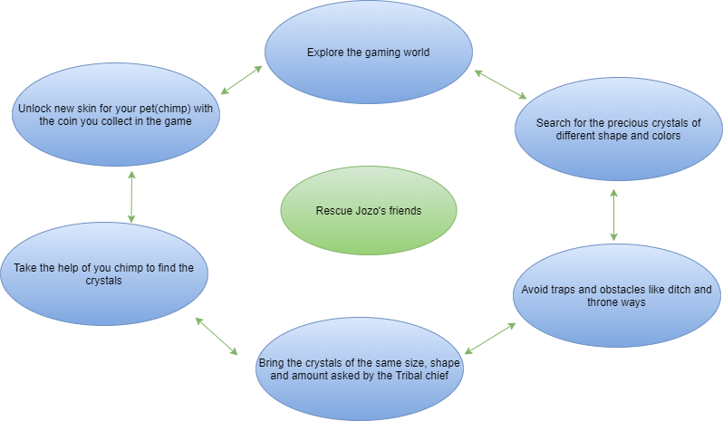

# Character:

Jozo: He is the main character of the game which is controlled by the players.

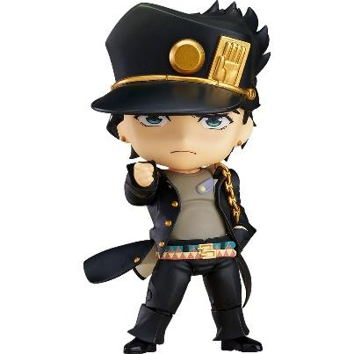

Chimpy: Chimpy is a monkey that helps Jozo to search crystals in the game world and Chimpy is automatic ai which leaders towards the area where gems can be found. With the help of powerful intelligence and researching ability Chimpy helps its master Jozo to find crystals. Chimpy loves bananas very much.





Tribal chief: Tribal chief is the chief of the unknown island inside the game. He is the one who had captured JoJo’s friends and asking for crystals of different shapes, colors, and quantities to set JoJo’s friends free.

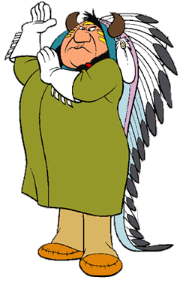

# Game world

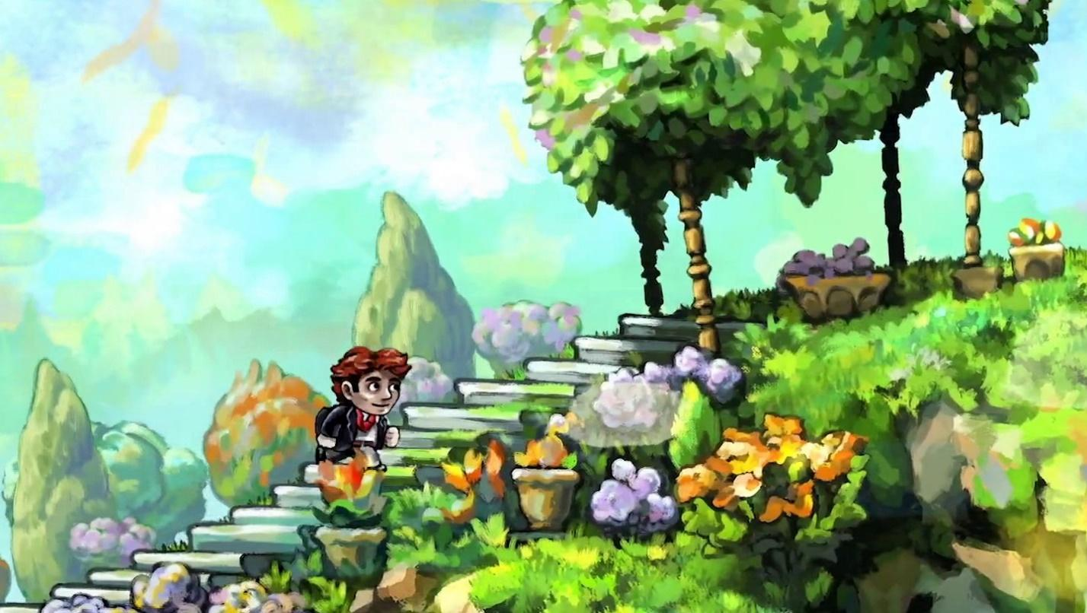

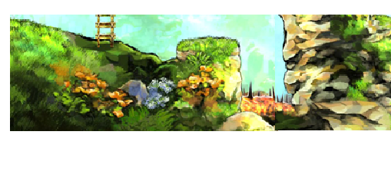

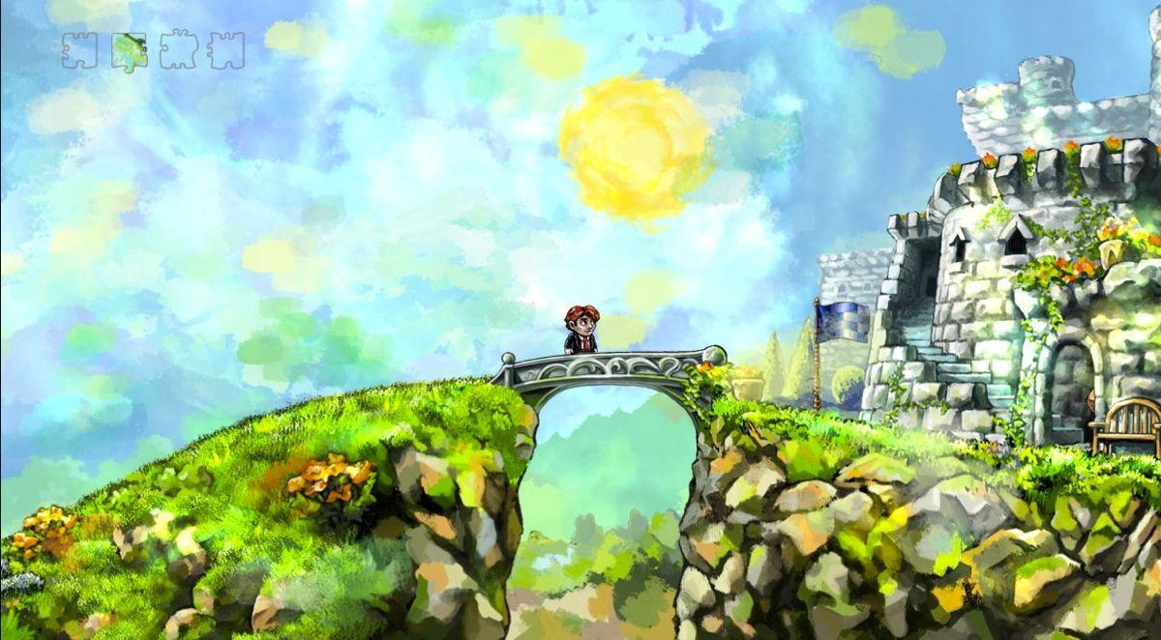

# Interaction

The player would be given the jump and side buttons to jump and move the character left to right.

To Jump:



To move left:



To movie right:



There would be a search option on the screen where players have to press to search the place where Chimpy is standing.

Search in screen touch

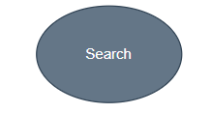

Search in keyboard

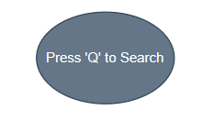

There would be a pick option on the screen where the player has to press to pick the object.

Pick in screen touch:

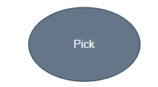

Pick in keyboard:

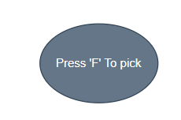

# Obstacles

In the game, obstacles will be the ditch and throne in the way and other crystals.

# Goals:

## Main goal

The main goal of the game is to rescue Jozo’s friend.

## Secondary goal

The secondary goal is to bring the same type and same quantity of crystals asked by the Tribal Chief.

# Obstacles

Other crystals which are not asked by the Tribal Chief, ditches, and throne paths are the obstacle of the game.

# About Crystals

## Shape:

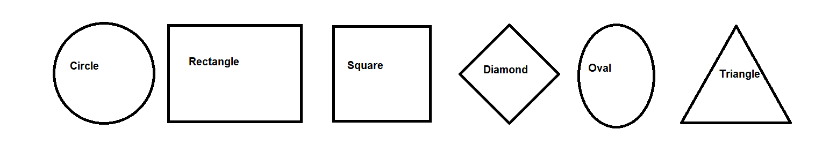

## Color:

Randomize all 12 colors.